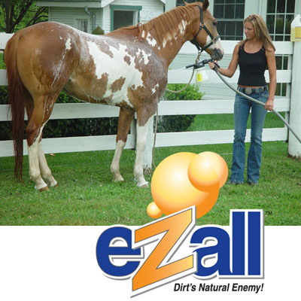
eZall Product Order Form

Mountain View Paint Horse Ranch LLC

Standing the Following APHA Stallions:
The Gift of Midas, 3rd at the 2007 World Show - HUS
^{NFR} Wiconi Warrior, 4th at the 2007 World Show - HUS
Product Quantity Pricing Total

Total Body Wash
- 1 Quart with Built in Sprayer ______ $14.99 ______
- 1 Gallon ______ $32.95 ______
- 5 Gallon Tote ______ $129.95 ______

Multi-Purpose Cleaner
- 1 Quart with Built in Sprayer ______ $14.99 ______
- 1 Gallon ______ $32.95 ______
- 5 Gallon Tote ______ $129.95 ______

eZ Foamer ______ $29.95 ______

Show-N-Go Detangler
- 1 Quart with Built in Sprayer ______ $22.50 ______
- 1 Gallon ______ $59.95 ______

Tail & Mane Treatment
- 32 Ounces ______ $19.95 ______
- 1 Gallon ______ $59.95 ______

It’s Gone – Adhesive Remover
- 16 Ounces ______ $12.95 ______
- 32 Ounces ______ $23.50 ______
- 1 Gallon ______ $65.00 ______

Ultimate Dust Control
- 32 Ounces ______ $19.95 ______
- 1 Gallon ______ $59.95 ______

Anivac (Wash / Vacuum System) ______ $299.00 ______

Sub-Total Order Cost $______
Arizona Sales Tax (if Arizona Address below) @ 6.3% $______
Total Order Cost $______

Shipping – Your FexEd / UPS / DHL Account #_________________ (No delivery charge to Arizona Paint Horse Shows)
Check # Attached __________
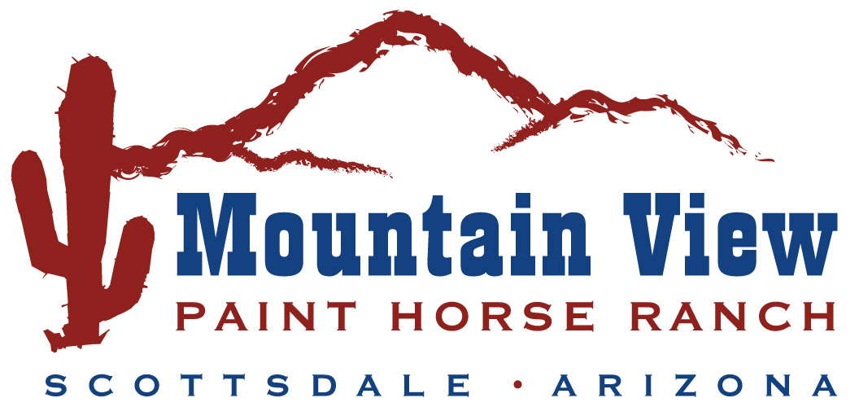
Ship To:
Name ___________________________________________
Contact __________________________________________
Address _________________________________________
City ____________________________________________
State __________________Zip ______________________

